Chapter 2 Waves and Particles
De Broglie wavelength: λ=h/p, where p is the momentum. If it is particle’s momentum, then p=mv=m₀v/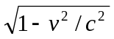 and λ= h()/m₀v; else if it is photon’s momentum, then p=E/c=hν/c, where h=6.626×10⁻³⁴ (J．sec)=4.136×10⁻¹⁵ (eV．sec) is Plank’s constant.
Eg. Find the de Broglie wavelengths of (a) a 46g golf ball with a velocity of 30m/sec, (b) an electron with a velocity of 10⁷m/sec
(Sol.) (a) ∵ v<<c, λ=h/p=h/m₀v=6.626×10⁻³⁴/(46×10⁻³×30)=4.8×10⁻³⁴(m)
(b) v=10⁷m/sec, λ=h/p=h()/m₀v=7.3×10⁻¹¹(m)
Quantum energy of one photon: E=hν=hc/λ=1.24×10⁻⁶/λ=pc.
Static mass of one photon: m₀=hν/c².
2-1 Photoelectric Effect E=hν=K_{max}+hν₀
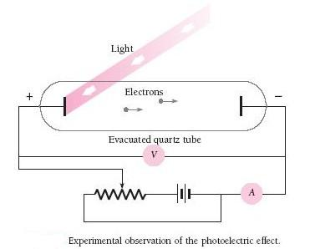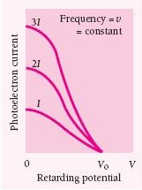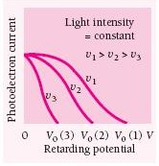
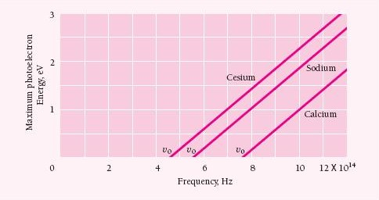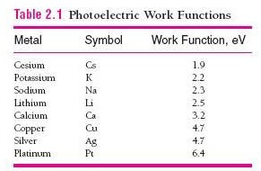
Photoelectric Effect: E=hν=K_{max}+hν₀=Maximal electron’s energy + Work function
Eg. An UV light of wavelength 350nm and intensity 1W/m² is incident at the potassium surface. (a) Find the maximum kinetic energy of photoelectrons. (b) If 0.5 percentages of the incident photons produce photoelectrons, how many photoelectrons/sec are emitted if potassium surface has an area of 1cm²?
(Sol.) (a) Work function of K=2.2eV=hν₀. E=1.24×10⁻⁶/350×10⁻⁹=3.5eV,
K_{max}=E-hν₀=3.5-2.2=1.3eV
(b) 3.5eV=3.5×1.602×10⁻¹⁹=5.68×10⁻¹⁹J, n_{p}=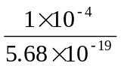=1.76×10¹⁴photons/sec
1.76×10¹⁴×0.5%=8.8×10¹¹photoelectrons/sec
Eg. Blue light of wavelength 300nm and intensity 0.5W/m² is directed at a material with work function of 2.7eV. (1) Find the maximum kinetic energy of photoelectrons. (2) If the quantum efficiency is 1%, how many photoelectrons are emitted per second if the semiconductor surface has an area of 2cm²? [台大電研]
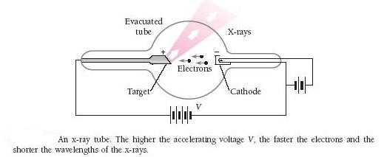
The shortest wavelength of X-ray due to electron bombard: λ_{min}=1.24×10⁻⁶/V, where V is the accelerating voltage.
Eg. Find the shortest wavelength present in the radiation from an X-ray machine whose accelerating potential is 50000V.
(Sol.) λ_{min}=1.24×10⁻⁶/50000=2.5×10⁻¹¹m=0.025nm

2-2 Bragg’s Reflection 2dsinθ=nλ and Compton Effect △λ=h(1-cosφ)/m₀c
Bragg’s Reflection: When 2dsinθ=nλ occurs, it forms a constructive interference.
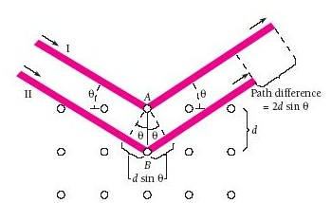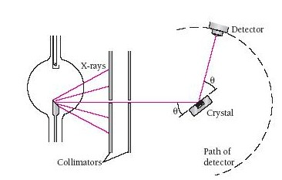
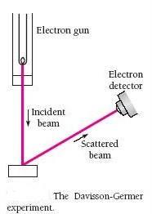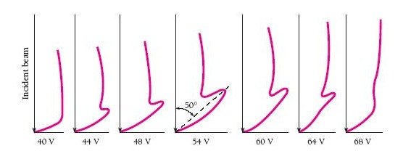
Eg. The distance between adjacent atomic planes in calcite is 0.3nm. What is the smallest angle between these planes and an incident beam of 30pm X-rays at which scattered X-rays can be detected?
(Sol.) d=0.3×10⁻⁹, λ=30×10⁻¹², 2dsinθ=nλ=λsinθ=0.05, θ=2.86°

Compton Effect: △λ=h(1-cosφ)/m₀c
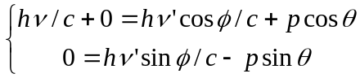(pc)²=(hν)²-2hν．hν’cosφ+(hν’) ²…(1)
And E=K+m₀c²=(hν-hν’)+m₀c²(pc)²=(hν)²-2hν．hν’+(hν’)²+2m₀c²(hν-hν’) …(2)
(1), (2)(m₀c/h)(ν/c-ν’/c)=(ν/c)(ν’/c)(1-cosφ)λ’-λ=△λ=h(1-cosφ)/m₀c
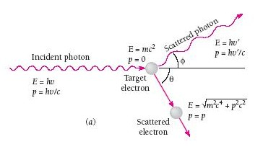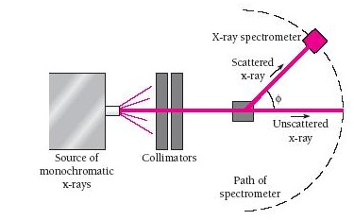
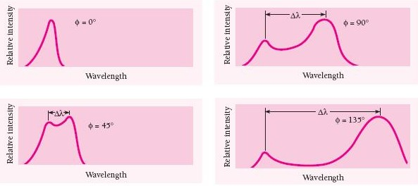 Compton wavelength: λ_{c}=h/m₀c, and the Compton wavelength of the electron is λ_{c,electron}=2.426×10⁻¹²m
Eg. A beam of X-rays is scattered by a target. At 45° from the beam direction the scattered X-rays have a wavelength of 2.2pm. What is the wavelength of the X-rays in the direct beam?
(Sol.) φ=45°, λ’=2.2pm, h/m₀c=2.426×10⁻¹², λ’-λ=h(1-cosφ)/m₀cλ=1.54pm

2-3 Photon, Gravity, and Black Holes
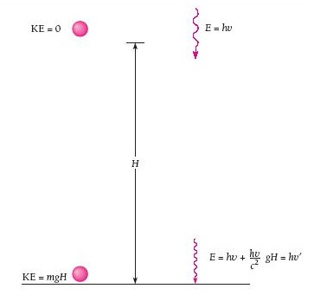
Eg. Find the change in frequency of a photon of red light whose original frequency is 7.3×10¹⁴Hz when it fall through 22.5m.
(Sol.) H=22.5, △ν=gHν/c²=1.8Hz

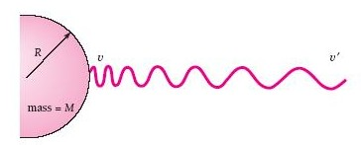
Gravitational red shift: The frequency of a photon emitted from the surface of a star decreases as it moves away from the star. And its total energy becomes E=hν-GMm/R=hν-GM(hν/c²)/R=hν’
△ν/ν=(ν-ν’)/ν==(1-ν’/ν)=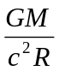
- For most stars, M/R is small, △ν/ν is not apparent.
- For white dwarf stars, M/R is large, △ν/ν is measurable.
- For black holes, if ≧0.5, we can obtain Schwarzschild radius R_{s}=2GM/c², and prove that no photon can leave the black holes.

